Sammies-Trial-API-Client

API client Details
Date Created: 05/29/2020 10:52 AM
The API client has been successfully created. To ensure the security of your project, the credentials are accessible only at the time you create it. Please make sure to save the credentials in a secure location.
Client credential flow
More information
Use these credentials to access the project via API:

samuels-intro-task

project_key

samuels-intro-task

client_id

dAy6Ml78zM_cn6EuBdnDGN6_

secret

J5FsYvggk96lVHRC4LeH8hDmmlFLjiYg

scope

manage_project:samuels-intro-task

API URL

https://api.us-central1.gcp.commercetools.com

Auth URL

https://auth.us-central1.gcp.commercetools.com

You can download the credentials in various formats below. Doing so may assist you in using the credentials in cURL, an SDK or in other environments.
cURL

curl https://auth.us-central1.gcp.commercetools.com/oauth/token \
--basic --user "dAy6Ml78zM_cn6EuBdnDGN6_:J5FsYvggk96lVHRC4LeH8hDmmlFLjiYg" \
-X POST \
-d "grant_type=client_credentials&scope=manage_project:samuels-intro-task"

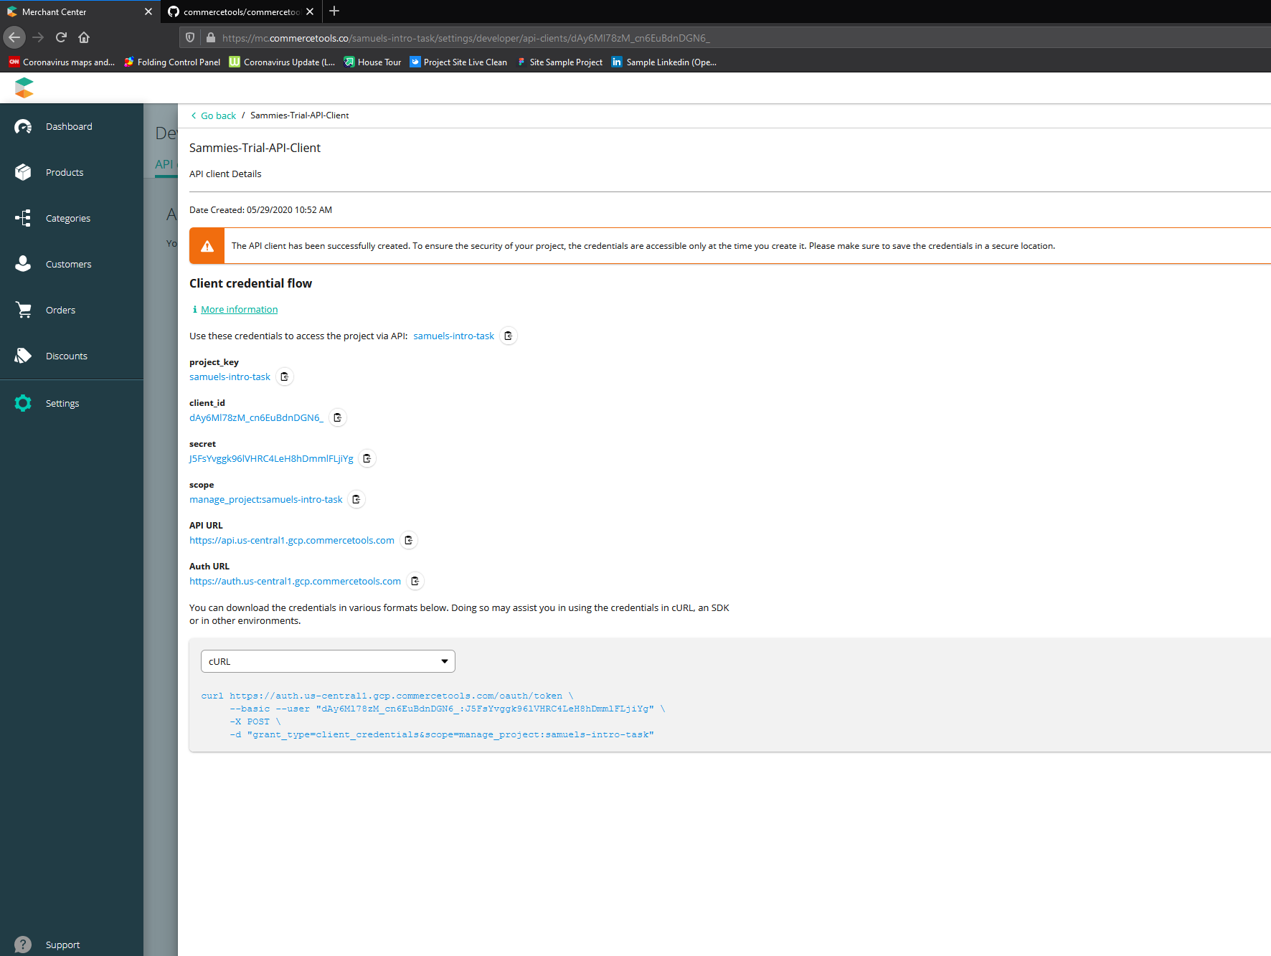
Language stuff

sunrise.ctp.client {

